**Handbook on**

**Entrepreneurship Mindset**

# 

**Thank You for Being the Changemaker!**

Thank you for leading with vision, for believing in your students, and for committing to a defining moment in Punjab’s journey, *one where classrooms become not just spaces of learning, but launchpads of possibility.*

The **Punjab Entrepreneurship Mindset Program** is a step towards transforming education into lived experience, *where students learn by building, think independently, and solve real-world problems with courage and creativity.*

This transformation is possible because of **YOU**.

Your leadership, your support, and your belief in experiential learning have laid the foundation for thousands of students to take their first steps as entrepreneurs. Because of your conviction, young minds across Punjab will now experience entrepreneurship not just as a concept, but as a reality.

This handbook is only a small reflection of that mission. The real change will begin in your classrooms, through your conversations, your encouragement, and your continued commitment.

**Every student registration, every venture started, every milestone reached, will trace back to YOU. Your belief. Your leadership. Your bold step forward.**

This program will go as far as your guidance takes it. And with your vision at the helm, the impact will be nothing short of extraordinary.

Thank you for leading the change.

**Table of Contents**

About the Program 4

Why Innovation and Entrepreneurship? 4

Structure - Entrepreneurship Mindset 6

Introduction 6

Learning Objectives 7

Learning Outcomes 7

Syllabus Overview: 8

Syllabus Overview by Term 9

Term 1: Setup & Launch 9

Term 2: Marketing Basics 9

Term 3: Operations & Scale 9

Term 4: Organic Growth 9

Term 5: AI Automation & Financial Mastery 9

Recommended Readings 10

Term Snapshot 11

Introduction 11

Learners Objective 11

Outcome 11

Guiding Principles/Approach 11

Content Creation - Term 1 Syllabus: 12

E-commerce - Term 1 Syllabus: 15

Professional Services - Term 1 Syllabus: 18

Overview of Business Tracks across all Terms 22

Overview : E-Commerce 22

Overview : Professional Services 23

Overview : Content Creation 24

App Demo- “Your Guided Journey to Building Entrepreneurial Skills” 25

Part 01: Onboarding 25

Part 02: Exploring the App After Login 28

Closing Note 36

# **About the Program**

Punjab stands at a pivotal moment where the potential of its youth must align with the evolving demands of the economy. The state has made tremendous strides in higher education, with the gross enrollment ratio increasing from 19.4% in 2011 to 27.4% in 2021. However, despite these impressive gains, the challenge of employability remains a pressing issue. Graduates are facing a widening gap between their academic qualifications and the skills required by the job market. The need for transformative solutions has never been more urgent, especially when we consider that less than 15 lakh formal-sector jobs are added annually in India, while over 1.5 crore students graduate every year. Punjab's own struggle is evident, with fewer than one lakh formal job opportunities available for its graduates.

This scenario calls for a paradigm shift in how we view higher education and employment. No longer can universities be seen merely as stepping stones to government jobs or traditional private sector roles. Instead, they must become breeding grounds for innovation, entrepreneurship, and economic self-reliance. In response to these challenges, the Punjab Start-Up Program has been launched to empower the youth, cultivate a spirit of innovation, and foster a robust entrepreneurial ecosystem.

## **Why Innovation and Entrepreneurship?**

In today’s rapidly evolving global landscape, traditional models of employment are increasingly insufficient to sustain economic growth, particularly in emerging economies like India. This is where innovation and entrepreneurship play a pivotal role. Let’s break it down in more detail.

1. **Addressing the Employability Gap**

One of the main challenges facing Indian youth today is the significant employability gap. While a large number of students graduate each year, the modern job market increasingly rewards those who can blend academic knowledge with real-world application. Entrepreneurship and innovation are critical to addressing this challenge by shifting the mindset from "job-seeking" to "job-creating."

1. **Fostering a Culture of Innovation**

At the core of entrepreneurship lies innovation – the ability to develop new ideas, create solutions to existing problems, and apply those ideas effectively. Entrepreneurial thinking fosters a culture where individuals are not only encouraged to think creatively but also empowered to act on their ideas. The integration of this entrepreneurship will play a powerful role in nurturing innovation, building resilience, and preparing students to thrive in a dynamic world.

1. **Boosting Social Change and Local Development**

Entrepreneurship doesn’t just fuel economic growth; it also drives social change. Entrepreneurs often work to solve societal issues, create inclusive growth, and promote sustainable development. By embracing an entrepreneurial mindset, individuals can positively influence their local communities and beyond. This initiative emphasizes not only business skills but also social entrepreneurship, ensuring that students contribute to creating positive social impact through their ventures.

1. **Inspiring a New Generation of Problem Solvers**

By embedding entrepreneurship in higher education, this program aims to revolutionize the way young people think about work and the economy. Students begin to identify local problems, design solutions, and turn ideas into action. This builds confidence, self-reliance, and a stronger sense of purpose in their personal and professional journeys.

# 

# 

# 

# 

# 

# 

# **Structure - Entrepreneurship Mindset**

There will be 5 termsthrough the student's journey!

Here’s a breakdown of what you can expect:

## **Introduction**

This course provides students with a holistic framework to develop entrepreneurial skills across the student's journey. The curriculum covers core principles of entrepreneurship, including identifying business opportunities, setting up operations, marketing, scaling, and financial management.

Throughout the program, students will choose from 3 specialized tracks:

1. **E-commerce:** In this track, students will learn how to build, manage, and scale an online business. From setting up an e-commerce platform to managing digital marketing strategies, inventory, and customer experience, this specialization provides the tools needed to succeed in the rapidly growing digital marketplace.
2. **Content Creation:** This track focuses on empowering students to create, curate, and market digital content across various platforms. Students will learn how to build a personal or brand identity, develop engaging content, and monetize their platforms, whether through social media, video production, blogging, or influencer marketing.
3. **Professional Services:** In this track, students will learn how to capitalize on freelance and contract-based opportunities. They will explore strategies for building a sustainable service-based business, manage client relationships, and maximize the flexibility that comes with this track.

The focus is on practical application, with students engaging in real-world projects that culminate in the creation and scaling of a business.

### 

### **Learning Objectives**

By the end of this course, students will be able to:

* Understand and apply entrepreneurial principles to real-world business situations.
* Develop and implement business strategies across different industries.
* Use digital tools, including AI, to enhance and automate business operations.
* Build sustainable business models, manage financials, and scale operations.

### **Learning Outcomes**

After studying this course, students will be able to:

* Launch and manage a business within their chosen track.
* Identify profitable opportunities and develop innovative solutions.
* Implement marketing and sales strategies using both digital and traditional methods.
* Use financial metrics to track performance and make informed business decisions.
* Scale a business using operational systems and automation tools.

The aim of this course is to ensure that, by the end, learners acquire essential entrepreneurial competencies such as **strategic thinking, practical application, founders & growth mindset, operational skills,** and **foundational financial literacy.**

Given below is the term-wise breakdown of the course across 5 terms in a variety of degrees (BBA, BSc., B.Com, B.Voc, ITI and Polytechnic). Each term will earn the student **2 credits.**

### 

### 

### 

### 

### **Syllabus Overview:**

| **Term** | **Learning Focus** | **Learner's demonstration** | **Revenue Target** |
| --- | --- | --- | --- |
| 1 | Setup & Launch | **Understand. Create. Start.** | ₹10,000 |
| 2 | Marketing Basics | **Engage. Share. Grow.** | ₹40,000 |
| 3 | Operations & Scale | **Earn. Deliver. Expand.** | ₹80,000 |
| 4 | Organic Growth | **Attract. Retain. Build.** | ₹160,000 |
| 5 | AI Automation & Finance mastery | **Simplify.Track.Sustain** | ₹400,000 |

### 

### 

### **Syllabus Overview by Term**

#### **Term 1: Setup & Launch**

In Term 1, students will explore what entrepreneurship means and how it connects to their daily lives. They will learn to identify problems, shape simple business ideas, and test them in real settings. This term builds the foundation—mindset, observation, value creation, and action.

#### **Term 2: Marketing Basics**

In Term 2, students will learn how to attract customers and grow their visibility using digital platforms and community-based marketing strategies. Students will also begin to run paid advertising campaigns and learn how to optimize their marketing efforts.

#### **Term 3: Operations & Scale**

This term focuses on the day-to-day operations of running a business, including order fulfillment, customer service, and logistics. Students will also focus on scaling operations as demand grows, with an emphasis on managing resources effectively.

#### **Term 4: Organic Growth**

Students will learn how to grow their businesses organically, using referrals, partnerships, and community engagement. This term focuses on building a loyal customer base and using word-of-mouth marketing to increase reach and credibility.

#### **Term 5: AI Automation & Financial Mastery**

The final term prepares students for long-term sustainability. Students integrate AI to improve productivity, automate routine tasks, and enhance decision-making. They also dive deep into financial planning, learning to set income goals, track expenses, understand profit margins, and create simple financial forecasts. This term helps students solidify their entrepreneurial identity design systems for financial stability and scalability.

### **Recommended Readings**

**1. Start with Why – Simon Sinek**

Explains how great leaders and entrepreneurs inspire action by starting with a clear sense of “why.” Perfect for understanding purpose-driven entrepreneurship.

**2. The Lean Startup - Eric Ries**

A must-read on how to test ideas, build fast, and learn quicker ideas for first-time entrepreneurs trying to reduce risk and start smart.

**3. Contagious: How to Build Word of Mouth in the Digital Age - Jonah Berger**

Introduces how small ideas spread and how anyone can build buzz, useful for content creators and small sellers.

**4. Shoe Dog - Phil Knight (Founder of Nike)**

An inspiring story of how a college runner built one of the world’s biggest shoe companies with almost nothing. Very relatable in its early struggle phase.

**5. Rework - Jason Fried & David Heinemeier Hansson**

Offers fresh, simple ideas about doing business differently. Ideal for breaking traditional thinking and seeing how less can be more.

**6. Ikigai: The Japanese Secret to a Long and Happy Life - Héctor García & Francesc Miralles**

Helps students reflect on passion, purpose, and how to connect what they love with what the world needs perfect for Value Map exercises.

**7. Tools of Titans (Selected Chapters) - Tim Ferriss**

Pick short, digestible parts from interviews with entrepreneurs, creators, and doers. Recommended as optional deep-dives.

**8. Zero to One: Notes on Startups, or How to Build the Future - Peter Thiel co-written with Blake Masters**

Indian, relatable, and deeply practical. Breaks down failure, money, motivation, and mindset in a raw and honest way.

**9. Romancing The Balance Sheet - Anil Lamba**

This book will teach you all the intelligent ways of Good Financial Management.

**10. Young Entrepreneurs (Series) - The Better India / YourStory articles**

Real Indian stories of youth starting businesses, snackable reads that show what’s possible.

# **Term Snapshot**

**Term : 1 | Entrepreneurship 101 (Setup & Launch)**

### **Introduction**

This term lays the foundation for the learner to understand what entrepreneurship is, beyond just starting a business. It introduces key ideas like problem-solving, value creation, and self-awareness. The learner will begin exploring basic business concepts while discovering their own interests and strengths.

### **Learners Objective**

* Understand the core concepts of entrepreneurship through relatable, real-life examples.
* Begin to see themselves as problem-solvers and creators.
* Learn about business paths and choose one to try based on interest or local fit.
* Launch a micro-hustle (online or offline) to earn their first income.
* Build confidence and self-belief by doing.

### **Outcome**

By the end of this term, learners will start a simple business activity, earn their first income, and build belief in their ability to do business.

### **Guiding Principles/Approach**

This syllabus is built on principles of **experiential learning, growth mindset development**, and **identity-first learning**. Drawing from learning science and behavior design, the course shifts students from passive learning to *active doing*, where they try out small business activities in real contexts. The design helps students not just learn entrepreneurship, but begin to see themselves as entrepreneurs. Emphasis is placed on *small wins, peer collaboration, and locally relevant opportunities* to ensure learning feels achievable and connected to their realities. The curriculum focuses on conceptual understanding without heavy theory, combining *practical action, reflection, and collaboration*. By making progress visible and success feel possible, it plants the seeds of **self-reliance, initiative, and long-term motivation**.

### **Content Creation - Term 1 Syllabus:**

**Introduction :**

This term lays the foundation for the learner to understand entrepreneurship through content creation. It introduces key ideas like problem-solving, value creation, and self-awareness. The learner will explore how content can be used to share ideas, build trust, and even earn money, while discovering their own interests, skills, and voice as a creator.

**Learners Objective:**

* Understand the key principles of content creation as a business venture.
* Change their perceptions about business from a risky affair to an opportunity to thrive
* Begin to see themselves as problem-solvers and creators.
* Understand monetization techniques in content creation and implement those strategies to earn their first income.
* Build confidence and self-belief by doing in their ability to do a business

**Outcome:** By the end of this term, learners will start creating and sharing content, earn their first income through it, and build confidence in their ability to grow as a content creator.

**Syllabus:**

**Format:** 12 milestones across 12 weeks, 4 hours/week | 2 credits

**Revenue Target:** ₹10,000

**Theme:** Each week covers a milestone— a clear, achievable step designed to meet learning goals of the term. *Each milestone is split into 2-3 tasks which enables a practical approach. Each task is supported by videos, reading materials, a detailed assignment which mirrors the real-world scenarios followed by a quiz to ensure retention.*

| **Weekly Milestone #** | **Milestone Title** | **Milestone Description** |
| --- | --- | --- |
| 1 | **Start your journey as a content creator** | Learn how to get thousands of followers online by creating content |
| 2 | **Decide your content topic** | Find that one topic you’re excited to create content about and who it’s meant for |
| 3 | **Start your own content channel** | Launch your official channel on YouTube or Instagram and start building your fanbase |
| 4 | **Plan your first week content calendar** | Learn how to create a simple weekly content calendar that keeps you consistent and stress-free |
| 5 | **Plan and record your first video** | Learn how to create a clear and catchy script for your first video and shoot it using your phone |
| 6 | **Edit and launch your first video** | Learn how to edit your video with trendy music and cool effects and launch your channel with first video |
| 7 | **Reach first 100 followers** | Use WhatsApp and personal Instagram account to tell people about your channel and reach first 100 followers/subscribers |
| 8 | **Master the skill of engaging people with your content** | Learn how to connect with your audience so they stay engaged and feel involved |
| 9 | **Grow your followers using trends and famous channels** | Learn how to use trending topics and tag well-known channels or creators to boost your reach and attract more followers |
| 10 | **Learn how you can make money from your content** | Discover how to do brand deals and promote brands or products your followers truly care about |
| 11 | **Make your first partnership** | Reach out to 10 brands for partnership and turn one into your first paid deal |
| 12 | **Plan your business growth** | Create a 1 month plan on what to post on a weekly basis to grow your followers and earn money |

**Weekly Component:**

Each week of the course follows a structured format designed to guide students from learning to doing, using simple, mobile-accessible components:

| **Component** | **Duration** | **Description** |
| --- | --- | --- |
| Action Lab | ~2 hrs | - Hands-on task on the weekly concept  - Includes step-by-step guidance, templates, and worksheets  - Ends with a submission (e.g., video, reflection, or proof of action) |
| Learning Resources | Self-paced | - Videos, short readings, real-life stories, and tools to deepen understanding at their own pace |
| Check - in | Self-paced | - Quizzes & Reflection prompts |

### 

### **E-commerce - Term 1 Syllabus:**

**Introduction :**

This term lays the foundation for the learner to understand entrepreneurship through selling simple products online or in their local area. It introduces key ideas like problem-solving, value creation, and self-awareness. Learners will explore basic business concepts such as product selection, pricing, and promotion while discovering their own interests and strengths.

**Learners Objective:**

* Understand how E-commerce works and how individuals and small sellers earn by selling products online using simple tools and platforms.
* Apply basic market research to choose simple, useful, and affordable products by observing local needs, trends, and daily challenges.
* Set up a basic online store and create your first product listing with clear pricing, photos, and descriptions using free apps or platforms.
* Promote your product using personal networks, WhatsApp, social media, and simple messages to build interest and reach first customers.
* Build confidence and self-belief by making your first sale, talking to a customer, and tracking your income and growth as a business starter.

**Learning Outcome:** By the end of this term, learners will choose a product, sell it online, earn their first income, and build confidence in their ability to grow a small product-based business.

**Syllabus:**

**Format:** 12 milestones across 12 weeks, 4 hours/week | 2 credits

**Revenue Target:** ₹10,000

**Theme:** Each week covers a milestone— a clear, achievable step designed to meet learning goals of the term. *Each milestone is split into 2-3 tasks which enables a practical approach. Each task is supported by videos, reading materials, a detailed assignment which mirrors the real-world scenarios followed by a quiz to ensure retention.*

| **Weekly Milestone#** | **Milestone Title** | **Milestone Description** |
| --- | --- | --- |
| 1 | **Learn how to start selling online** | Learn what an E-commerce business is and how you can start selling online in less than 30 days |
| 2 | **Choose your product** | Explore different products and finalize what you want to sell online |
| 3 | **Find a supplier who will deliver the product for you** | Identify suppliers who can send your product directly to the customer and help you launch your E-commerce business |
| 4 | **Create your E-commerce store** | Make a simple online store using Shopify and learn how to upload product images and description on the store |
| 5 | **Activate payments on your store** | Learn how to link your bank account to your E-commerce store and start receiving payments |
| 6 | **Launch your online store** | Create a simple launch message and poster using Canva and use Instagram and WhatsApp to announce that your store is live |
| 7 | **Get first 100 people visit your online store** | Learn how to write simple and catchy messages to promote your store and send it to 100 people |
| 8 | **Make your first sale** | Convert one paying customer and learn how to process the order from beginning to delivery |
| 9 | **Create and post your first ad** | Learn how to design a simple promotional ad and post it to bring in more people and sales |
| 10 | **Take feedback from customers** | Engage with your paid customers, take product feedback, and upload success stories or reviews on your website |
| 11 | **Get a repeat customer or referral** | Build trust with your paid customers to get either a repeat order or a referral |
| 12 | **Plan your business growth** | Make a 1 month plan to promote and grow your E-commerce store and earn more money |

**Weekly Component:**

Each week of the course follows a structured format designed to guide students from learning to doing, using simple, mobile-accessible components:

| **Component** | **Duration** | **Description** |
| --- | --- | --- |
| Action Lab | ~2 hrs | - Hands-on task on the weekly concept  - Includes step-by-step guidance, templates, and worksheets  - Ends with a submission (e.g., video, reflection, or proof of action) |
| Learning Resources | Self-paced | - Videos, short readings, real-life stories, and tools to deepen understanding at their own pace |
| Check - in | Self-paced | - Quizzes & Reflection prompts |

### 

### **Professional Services - Term 1 Syllabus:**

**Introduction :**

This term lays the foundation for the learner to understand what entrepreneurship is, beyond just starting a business. It introduces key ideas like problem-solving, value creation, and self-awareness. The learner will begin exploring basic business concepts while discovering their own interests and strengths.

**Learners Objective:**

* Understand the basics of service-based business as a way to earn income.
* Shift their mindset from job-seeker to service provider by recognizing their own skills as valuable.
* Learn how to find customers, use platforms, and build trust to start offering services.
* Implement simple strategies like writing descriptions, setting prices, and creating proof to earn their first income.
* Build confidence and self-belief through real experience of offering and delivering paid services.

**Learning Outcome:** By the end of this term, learners will start offering their services, earn their first income through it, and build confidence in their ability to grow as independent service providers.

**Syllabus:**

**Format:** 12 milestones across 12 weeks, 4 hours/week | 2 credits

**Revenue Target:** ₹10,000

**Theme :** Each week covers a milestone— a clear, achievable step designed to meet learning goals of the term. *Each milestone is split into 2-3 tasks which enables a practical approach. Each task is supported by videos, reading materials, a detailed assignment which mirrors the real-world scenarios followed by a quiz to ensure retention.*

| **Weekly Milestone#** | **Milestone** | **Milestone Description** |
| --- | --- | --- |
| 1 | **Start your journey in professional services** | Learn what is a service and how you can earn money by offering your skill as a service |
| 2 | **Choose your service skill** | Choose one skill you are good at and turn it into a service that people will pay for |
| 3 | **Find your ideal customer** | Talk to people directly or through social media apps, understand who is willing to pay for your service and "WHY" |
| 4 | **Build your online profile and show what you offer** | Explore apps or websites such as WhatsApp Business, Upwork, or Urban Company, and learn how to create an online profile |
| 5 | **Write your service description** | Learn how to write your service in a simple and powerful way that gets people excited to try it |
| 6 | **Finalize your pricing** | Learn how to set a price your customer finds fair and is ready to pay |
| 7 | **Design basic posts to promote your service** | Learn Canva to design simple and clear posts that explain what your service is, why it’s useful, and how people can get it |
| 8 | **Offer a free service and learn from feedback** | Give your service for free to real users and use their feedback to make it better |
| 9 | **Make your first sale** | Reach out to 50 potential customers and start building revenue by selling your service |
| 10 | **Build trust with customers and get repeat orders** | Use your trust and good relationship with existing customers to get your first repeat customer |
| 11 | **Earn your first referral** | Start offering bonus or other additional services to your existing customers and get your first referral |
| 12 | **Plan your business growth** | Make a 1 month plan on how to get more customers and earn more money |

**Weekly Component:**

Each week of the course follows a structured format designed to guide students from learning to doing, using simple, mobile-accessible components:

| **Component** | **Duration** | **Description** |
| --- | --- | --- |
| Action Lab | ~2 hrs | - Hands-on task on the weekly concept  - Includes step-by-step guidance, templates, and worksheets  - Ends with a submission (e.g., video, reflection, or proof of action) |
| Learning Resources | Self-paced | - Videos, short readings, real-life stories, and tools to deepen understanding at their own pace |
| Check - in | Self-paced | - Quizzes & Reflection prompts |

**Evaluation Criteria**

| **Evaluation Component** | **Description** | **Weightage** |
| --- | --- | --- |
| **Weekly Task Completion** | Timely submission of weekly tasks, including activities, reflection prompts, graded quizzes etc | 60% |
| **Target Completion** | Performance-based evaluation on hitting revenue or profit targets (e.g., generating ₹10,000 revenue) | 20% |
| **Final Project** | A comprehensive project depending the theme of the term | 20% |

# 

# 

# **Overview of Business Tracks across all Terms**

## Overview : E-Commerce

| **Term** | **Theme** | | **E-commerce** |
| --- | --- | --- | --- |
| **1** | **Setup & Launch** | Identify opportunities, select the right products/services, and set up basic operations to get their business off the ground. | How to pick winning products & set up an online store |
| **2** | **Marketing Basics** | Learn how to attract customers and grow visibility using digital platforms and community-based marketing. | How to market products with social media |
| **3** | **Operations & Scale** | Focus on handling day-to-day business, managing customers, and expanding capacity as demand grows. | How to handle logistics, shipping, and customer service |
| **4** | **Organic Growth** | Learn to grow without heavy spending, by leveraging referrals, partnerships, and community engagement. | How to grow organically with community and referrals |
| **5** | **AI Automation & Finance Mastery** | Automate tasks with AI, streamline operations, and manage finances for sustainable growth. | How to use AI to scale your business, while also learning to track cash flow and reinvest profits for sustainable growth. |
|

## 

## 

## 

## Overview : Professional Services

| **Term** | **Theme** | | **Professional Services** |
| --- | --- | --- | --- |
| **1** | **Setup & Launch** | Identify opportunities, select the right products/services, and set up basic operations to get their business off the ground. | How to showcase your skills & start offering them as services |
| **2** | **Marketing Basics** | Learn how to attract customers and grow visibility using digital platforms and community-based marketing. | How to market your services online |
| **3** | **Operations & Scale** | Focus on handling day-to-day business, managing customers, and expanding capacity as demand grows. | How to handle multiple offers & clients |
| **4** | **Organic Growth** | Learn to grow without heavy spending, by leveraging referrals, partnerships, and community engagement. | How to get repeat clients & build loyalty |
| **5** | **AI Automation & Finance Mastery** | Automate tasks with AI, streamline operations, and manage finances for sustainable growth. | How to use AI to manage bookings and client messages, while also learning to track earnings and scale profitably. |
|

# 

# 

## 

## Overview : Content Creation

| **Term** | **Theme** | | **Content Creation** |
| --- | --- | --- | --- |
| **1** | **Setup & Launch** | Identify opportunities, select the right products/services, and set up basic operations to get their business off the ground. | How to define your niche & start posting content |
| **2** | **Marketing Basics** | Learn how to attract customers and grow visibility using digital platforms and community-based marketing. | How to grow your audience through engaging content |
| **3** | **Operations & Scale** | Focus on handling day-to-day business, managing customers, and expanding capacity as demand grows. | How to earn from content: ads & collabs |
| **4** | **Organic Growth** | Learn to grow without heavy spending, by leveraging referrals, partnerships, and community engagement. | How to grow followers & engagement without ads |
| **5** | **AI Automation & Finance Mastery** | Automate tasks with AI, streamline operations, and manage finances for sustainable growth. | How to use AI for content ideas, writing, and posting, while also learning to manage multiple income streams and profits. |
|

# 

# **App Demo**- **“Your Guided Journey to Building Entrepreneurial Skills”**

This section offers a visual overview of the Punjab Entrepreneurship Mindset Program App, built to facilitate experiential learning in entrepreneurship for students across the state. The app empowers learners to engage with real-world business tracks, complete structured weekly tasks, connect with experienced mentors, and access a supportive entrepreneurial community. A key feature of the platform is its integrated AI Assistant, which provides instant academic support, content summaries, and idea suggestions, enhancing the learning experience and enabling students to move at their own pace. Together, these elements create a comprehensive ecosystem to help students build confidence, skills, and ventures of their own.

## **Part 01: Onboarding**

This section provides a step-by-step walkthrough of how a new student signs up and explores the dashboard for the very first time.

**Step 1: Signing Up as a New User**

When a student clicks on **“New User? Sign Up”**, they begin by entering their **10-digit mobile number** to receive a One-Time Password (OTP).  
Once the **6-digit OTP** is entered and verified, they proceed to the next screen.

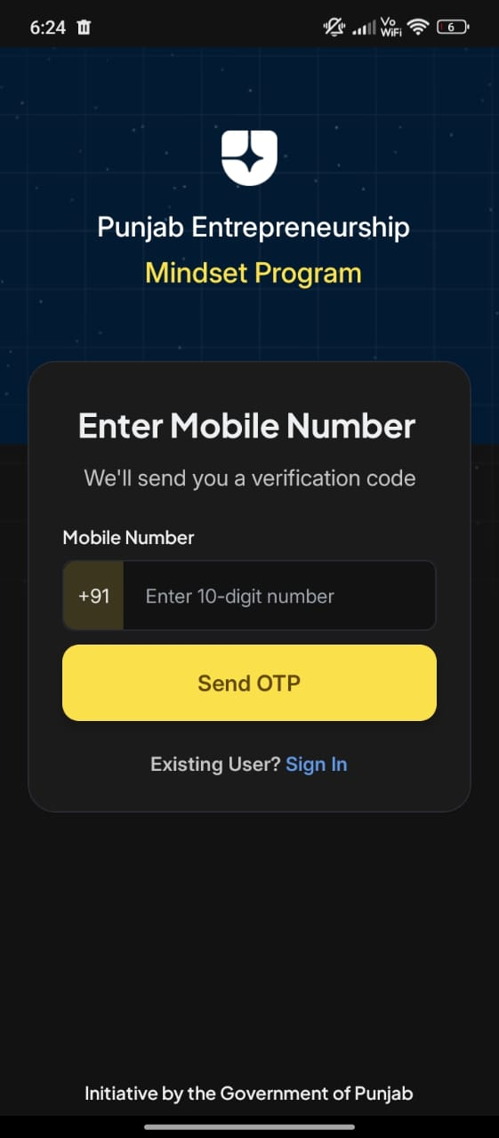 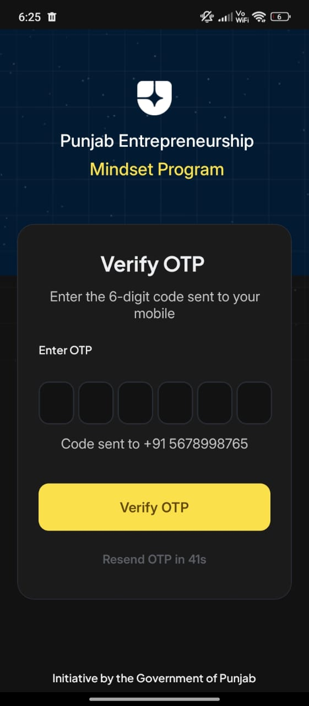

**Step 2: Entering Basic Details**

The student is prompted to fill in essential information:

* Full Name
* Gender
* Email Address
* Date of Birth
* A password of their choice (used for future login)

For this walkthrough, we are signing up as a student named **Raj**.

**Step 3: Education Details**

* The State (Punjab)
* The University and College Name
* University Roll Number
* Current Degree Program (e.g., BBA, B.Com, B.Tech)

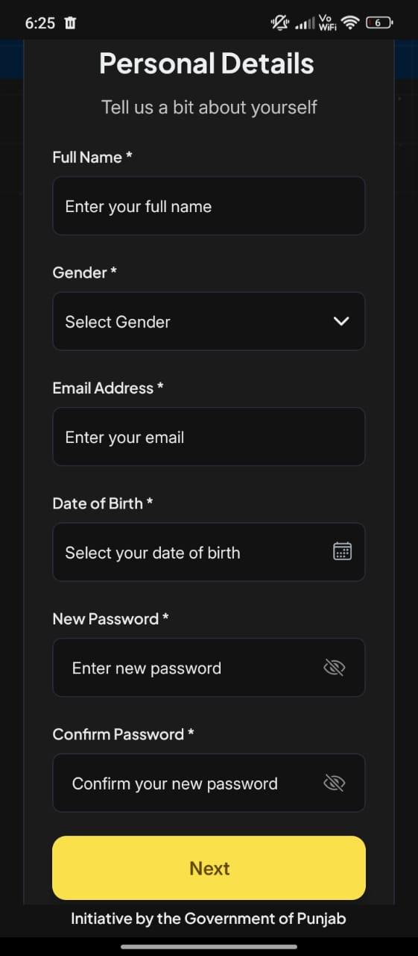 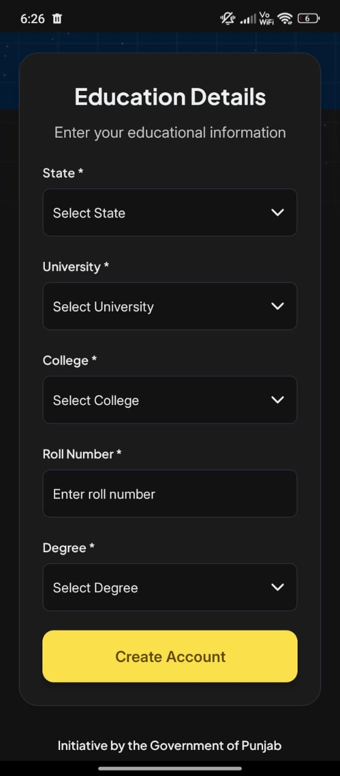

**Step 4: Language and Track Selection**

After creating the account, Simran selects a **preferred language** (English or Punjabi).  
She is then shown a list of **learning tracks**, such as:

* Content Creation
* Professional Services
* E-Commerce

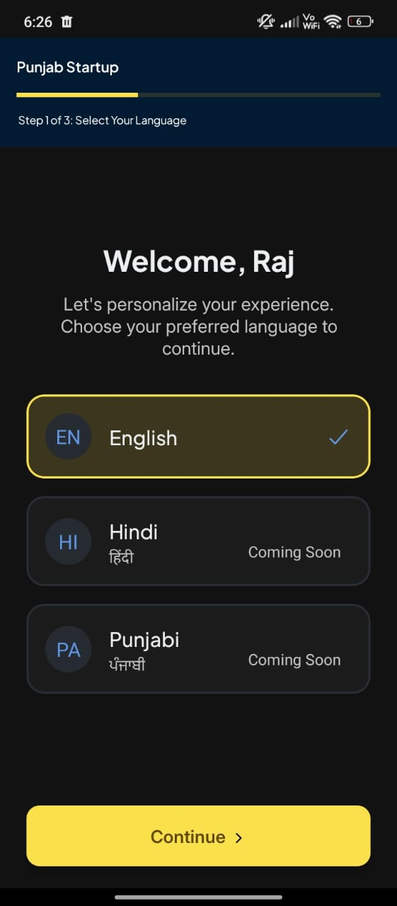 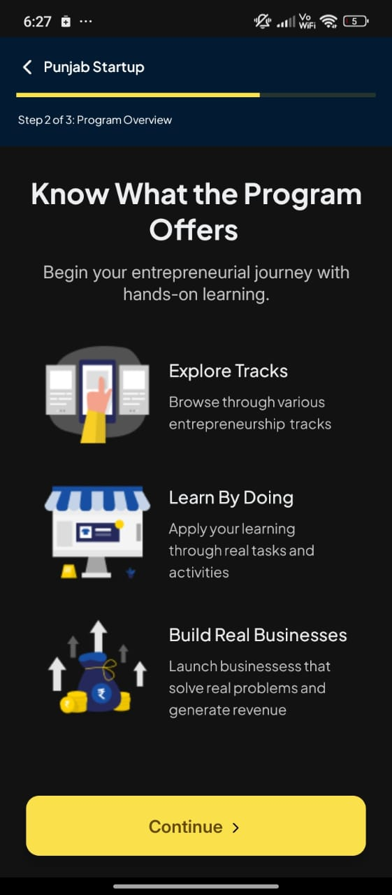

Each track card includes a **“Learn More”** option, where Simran can:

* Watch introductory videos
* Read brief descriptions
* Take a short **Track Alignment Quiz** to find the right fit

Once ready, she taps **“Start Your Journey”** to begin her learning experience.

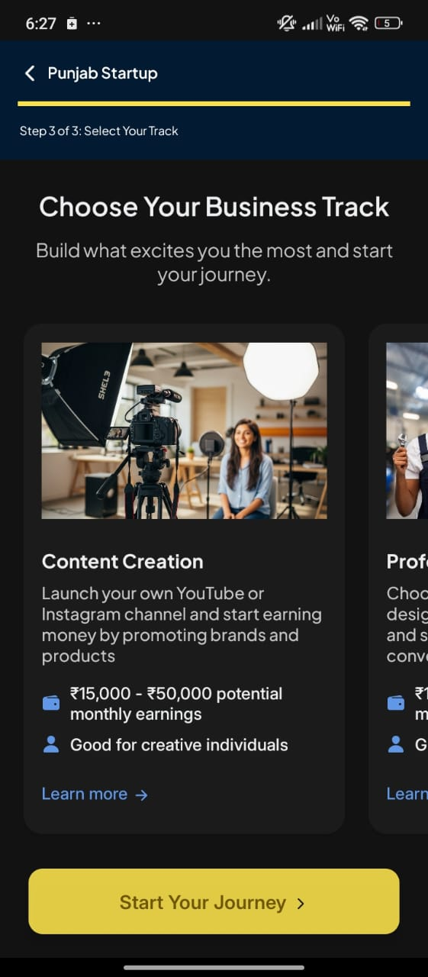 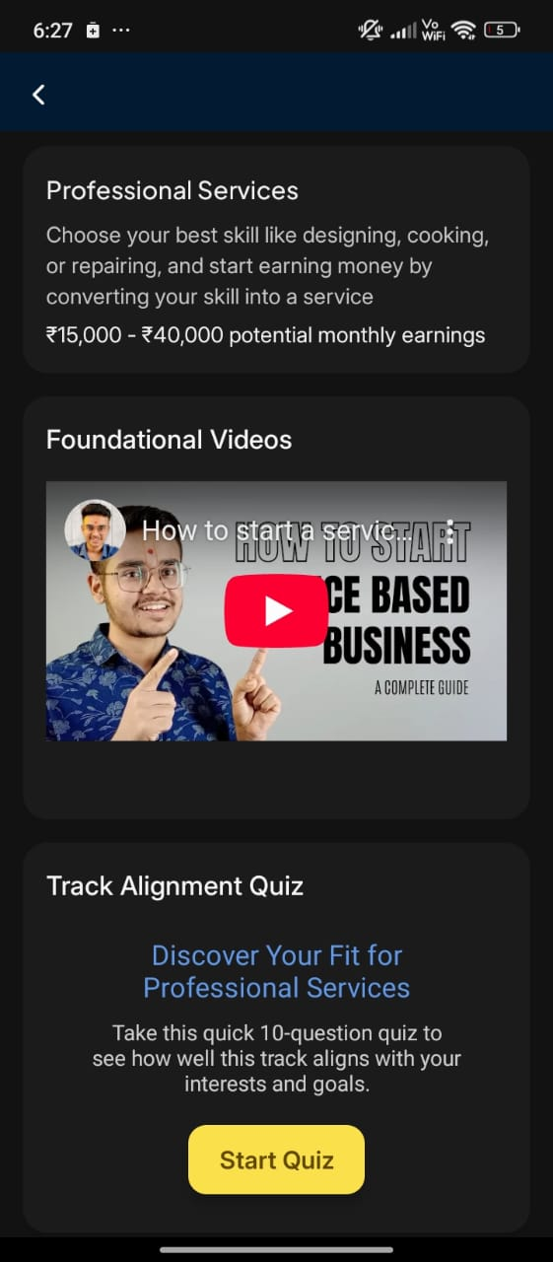

## **Part 02: Exploring the App After Login**

Once the student has successfully logged in, they are welcomed to the main dashboard designed to provide a clear, guided, and interactive learning experience.

The app interface is organized into **five core tabs**, each serving a unique function in the student's entrepreneurial journey:

1. **Home**

A dynamic overview of the student’s activity and opportunities. From here, students can track their rank, streak, and points, access events, view success stories, receive announcements, and quickly resume their learning journey.

1. **Track**

This is the heart of the learning experience. Students access their selected business track and unlock weekly modules that include videos, quizzes, action labs, and reflections all tailored to practical entrepreneurship.

1. **Progress *(Leaderboard)***

Students can view their personal performance-track completion, scores, streaks, and see how they rank among peers across Punjab. This feature promotes healthy competition and consistent engagement.

1. **Mentors**

Students can browse mentor profiles, book 1:1 sessions, or ask questions. This section fosters guidance, expert support, and real-world learning through curated mentor interactions.

1. **AI Assistant**

An intelligent chat-based companion available 24/7 to support students. Whether they need help understanding a concept, summarizing content, or asking for business ideas, the AI Assistant is just a message away.

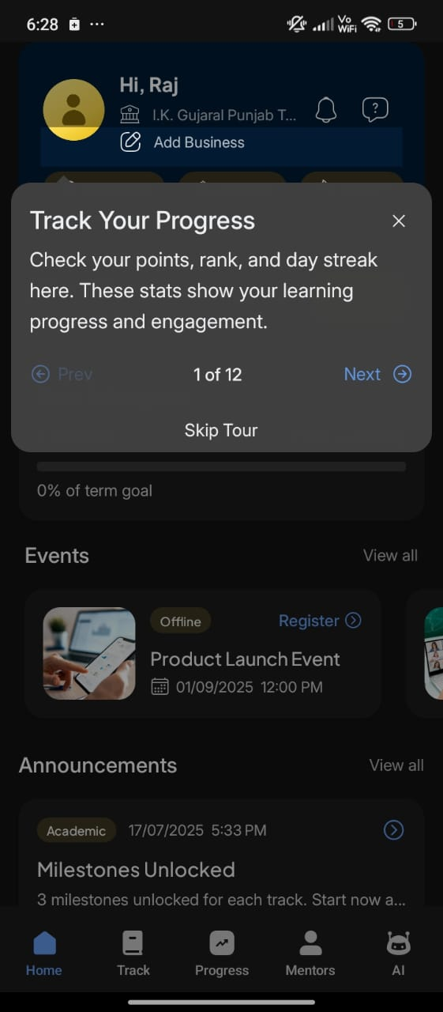 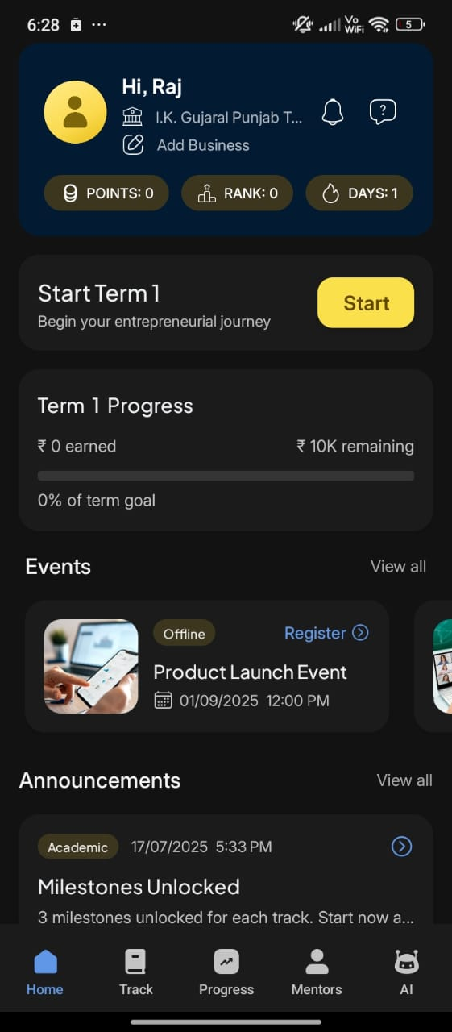

**Dashboard or the home screen** of the app looks like. Once the student enters the dashboard for the first time, they see a 12-step journey of the app tour where they are made aware of everything available on the dashboard.

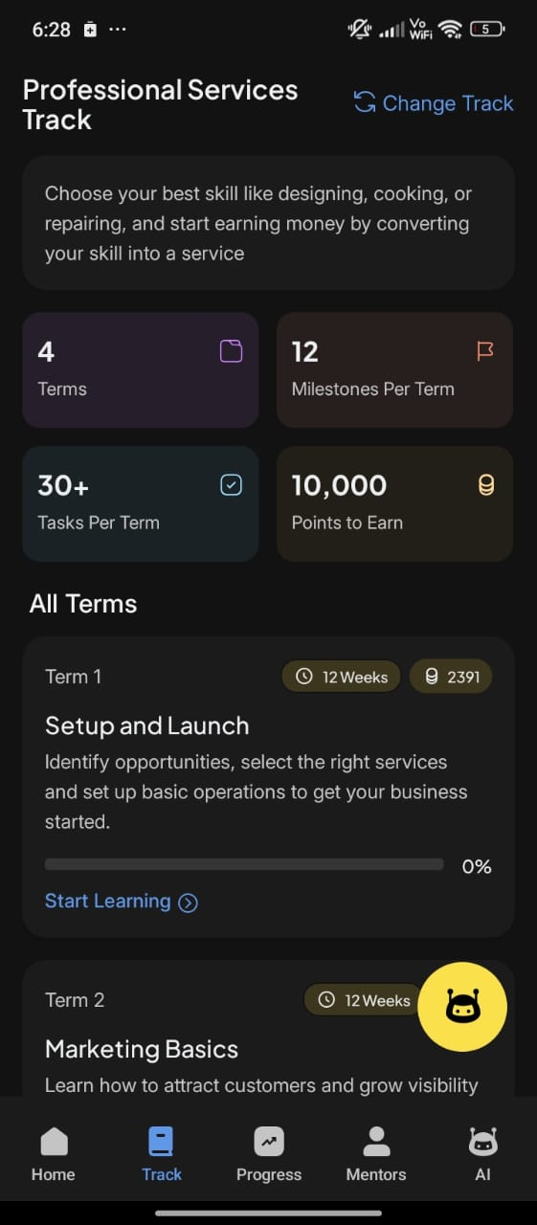 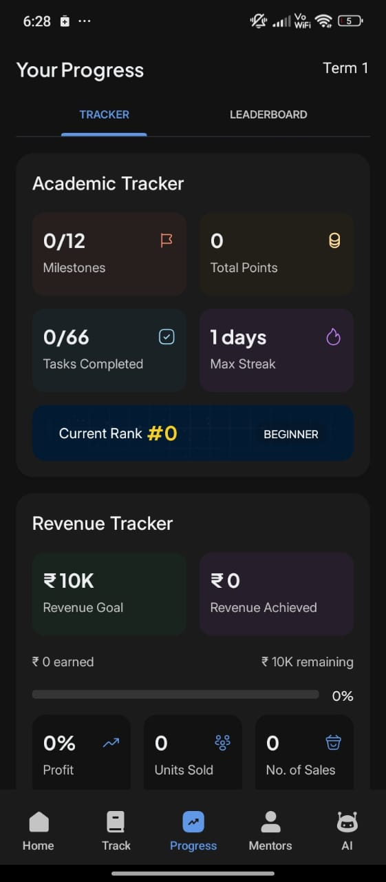

**By clicking on Track**, the student can see the entire curriculum of the track, divided into terms, milestones, tasks, and activities. By scrolling down, the term title and term description are clearly visible, helping students understand what they will be doing in each term.

**Progress Tracker** is where the students can see their academic tracker information such as the number of milestones completed, total points earned, tasks completed, and day streak.

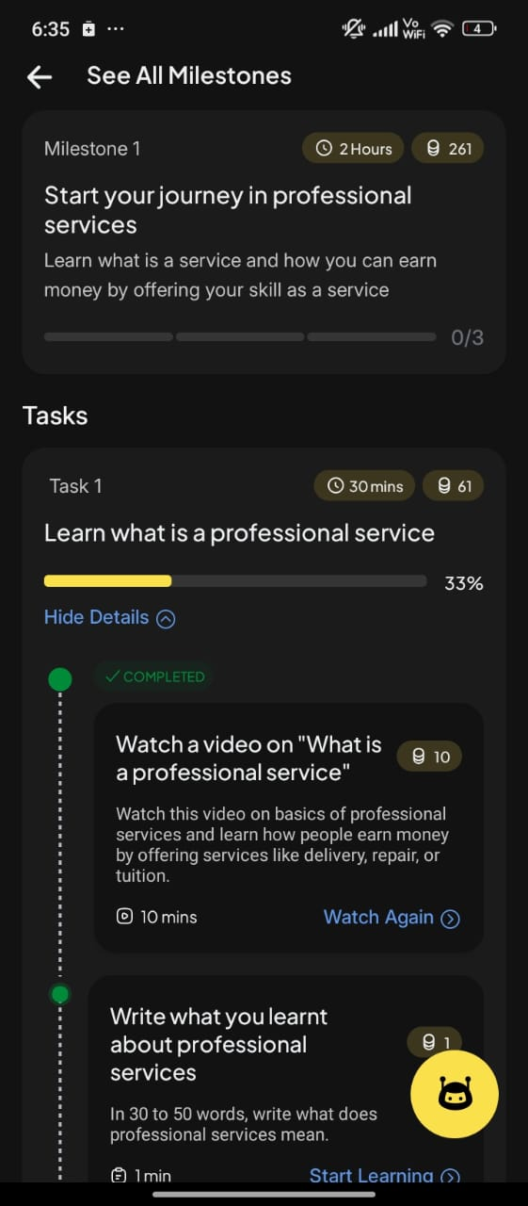 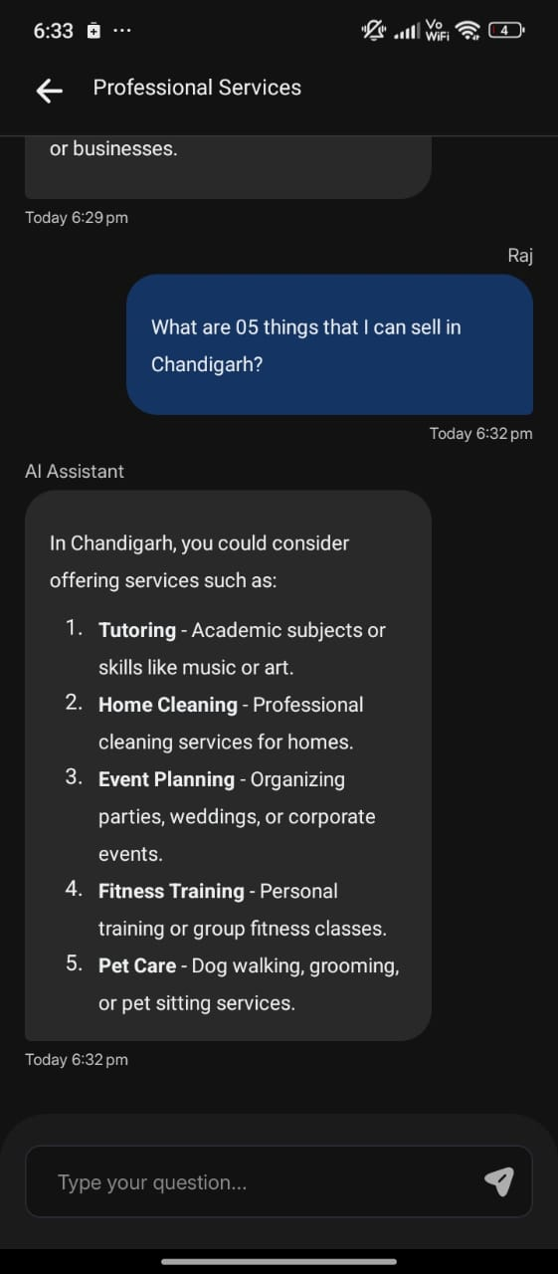

**AI mentor** right on the screen for the student. Once the student clicks on this icon, they can ask questions, and the AI mentor will provide instant guidance.

**Part 03: Adding Business**

**Helping Students Record Real Ventures**

One of the key features of the app is the ability for students to add and track real businesses they build during the program. The “Add Business” option is accessible directly from the Home screen/dashboard.

1. **Add Business Screen**

This screen allows students to fill in important details about their venture. The form includes fields such as:

* Business Name
* A short Business Description
* Business Category (e.g., E-commerce, Services, Food, etc.)
* Optional inputs like:
  + - Logo upload
    - Business Email and Contact Number
    - Website or Social Media links

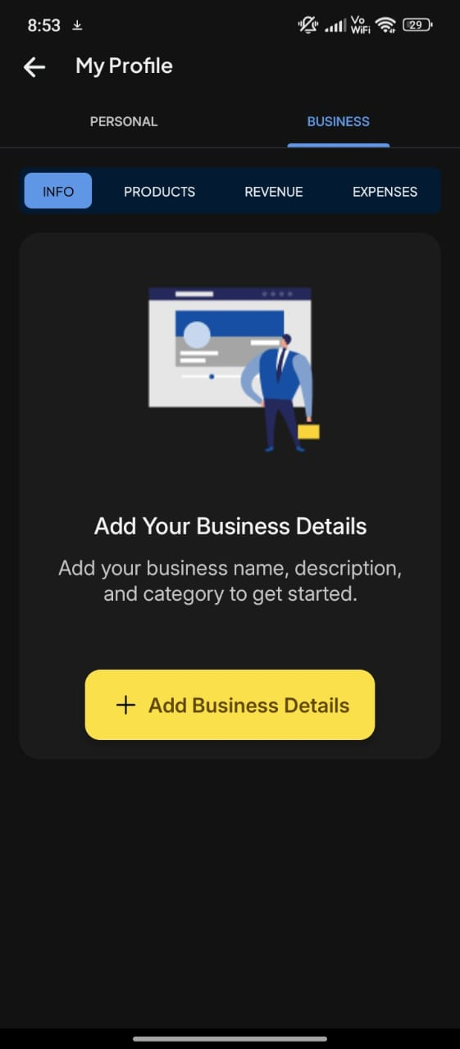 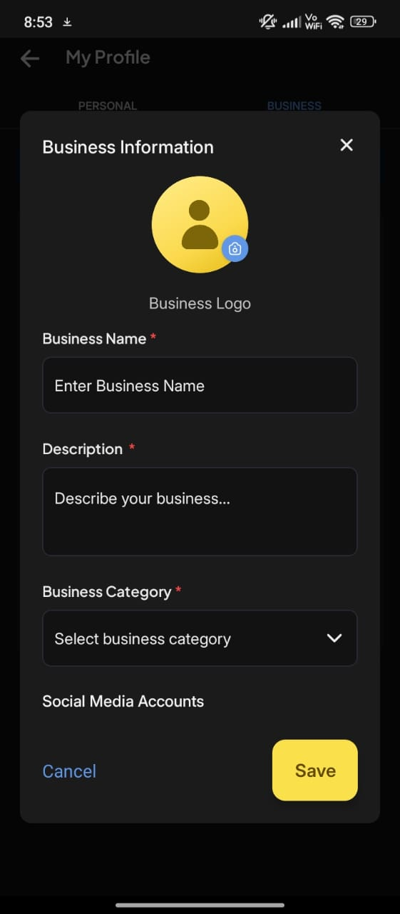

This screen provides a complete identity framework for the student’s startup.

1. **Products & Services Screen**

After creating the business, students are taken to a screen where they can add the products or services they offer. This includes:

* Product/Service Name
* Description
* Cost Price

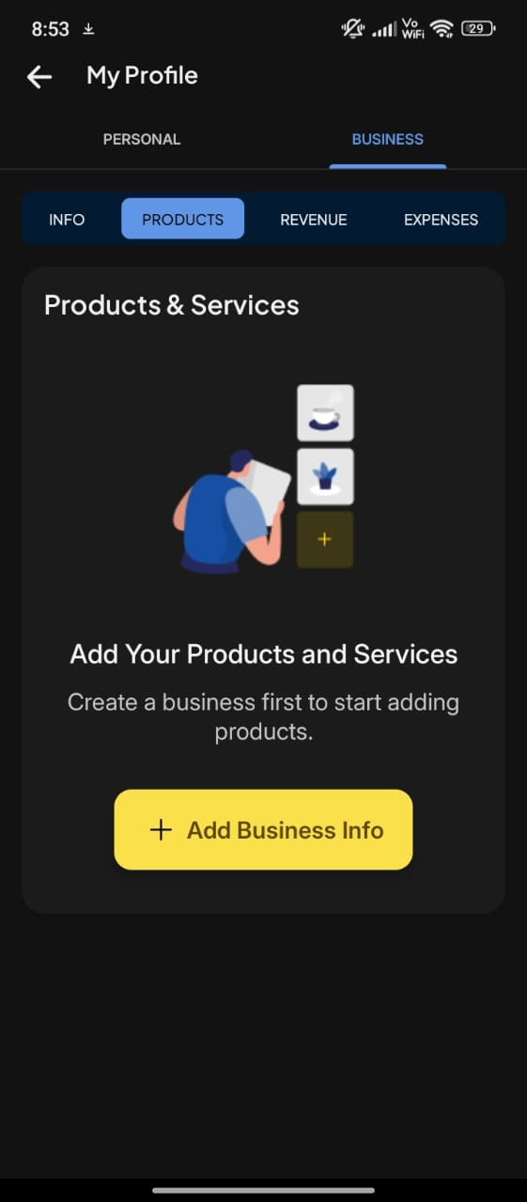 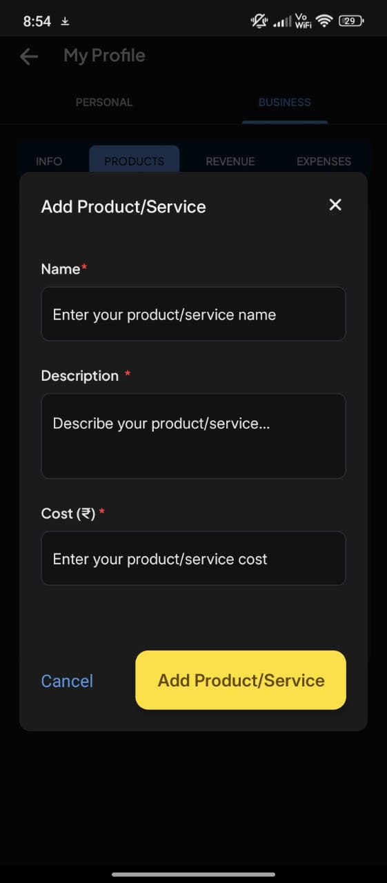

All added products appear in a list view, creating a catalog within the app.

1. **Revenue Entry Screen**

When students make sales, they can document each transaction on this screen. They need to fill in:

* The product sold
* Quantity sold
* Selling Price per unit
* Date of sale
* Upload field for Proof of Sale (optional but encouraged for verification)

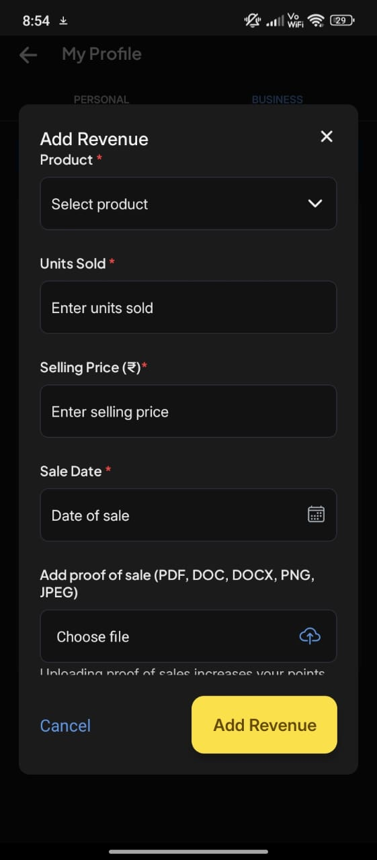

This helps students monitor earnings and validate business activity in a structured format.

1. **Business Expenses Screen**

This screen enables students to record any operational costs they incur such as logistics, printing, marketing, raw materials, or service fees. They can input:

* Expense Description
* Amount Spent
* Date of Expense
* Supporting notes or receipts (optional)

# 

Each of these screens is designed to simulate real-world business tracking and builds students' ability to manage their venture in a disciplined and verifiable manner.

# **Closing Note**

This course marks the beginning of a structured and immersive journey into the world of entrepreneurship. Through a focus on practical application, problem-solving, and mindset development, learners have taken their initial steps toward understanding what it means to think and act like entrepreneurs.

As learners continue through this program, they will build on this foundation with deeper exposure, real-world practice, and the confidence to pursue meaningful ventures. This curriculum is designed to grow with them, adapting to their needs and preparing them to create impact in their communities and beyond.

The journey ahead is one of learning, experimentation, and growth—and they are well prepared to take it on.